Interested in becoming a member of Huntley Project Museum?

Single Membership- $15
Family Membership- $25
Memberships are good for one year. With your membership the museum donation fee will be waived upon your visits. You will receive monthly museum newsletters and emails with upcoming events and museum happenings.
Please fill out information below and send along with a check to:
Huntley Project Museum
P.O. Box 353
Huntley, Montana 59037

--------------------------------------------------------------------
Name_____________________________________________

Address__________________________________________
___________________________________________________

Phone Number____________________________________

Email Address____________________________________

Single Membership @ $15

Family Membership @ $25

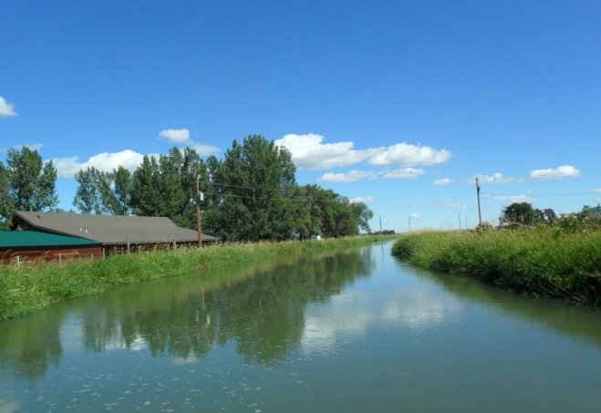
Huntley Project Museum of Irrigated Agriculture

September 2011 Newsletter
The Huntley Project Museum enjoyed a very busy
summer. Our visitor roster boasts names from all across the United States and around the world.

Summer kicked off with the annual Homesteader Days events. The museum’s visitor totals jumped up for the weekend. It was so wonderful to see everyone enjoying the festivities and taking a few moments to look around
the museum and take the walking tour of the museum’s outbuildings.

The car show was a success and we look forward to planning it again for next year. The 23rd Annual
Threshing Bee put on by South Central Montana Antique Tractor and Machinery Association helped bring even
more visitors to the museum.

The next event at the museum will be the Grand Opening
of the First National Bank, originally in Pompey’s Pillar,
on Saturday, September 24th 2011. Please join us from
12-4 and enjoy refreshments and a tour of the newly restored bank building.
Hope to see you soon!
Melissa Koch
Curator
curator@huntleyprojectmuseum.org
406-348-2533
Endless Summer Car Show
The car show featured 31 classic cars and one tractor for spectators to enjoy on August 14th, 2011. A big thanks goes to Huntley Project Wrestling team for making and selling burgers during the show; also Otis Oblander for selling his “Project Famous” hot dogs.
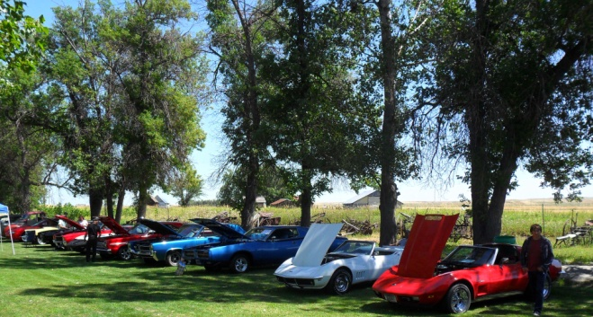

There were 20 different categories in which prizes were awarded. Best in Show went to Dale and Darlene Hert with their 1932 Ford Roadster.
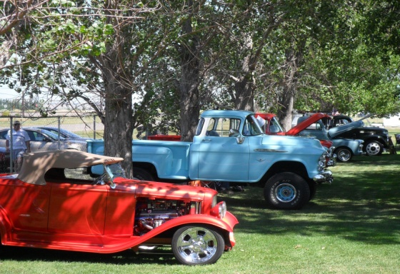

After the car show, questionnaires were sent to all participants and asked their opinions on how the car show went, possible date change for next year, and other questions that will help us put on a bigger and better car show next year.

Thanks to everyone who brought their cars and to the spectators as well. Hope to see you next year.
23rd Annual Threshing Bee
Hosted by the Antique Tractor and Machinery Association
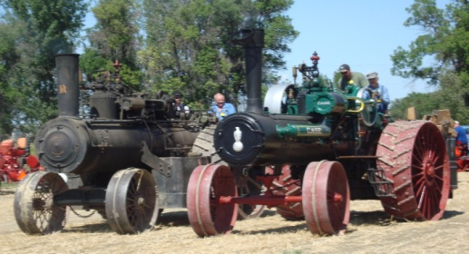

This annual event always draws a large crowd and this year was no exception with a rise in visitor totals.
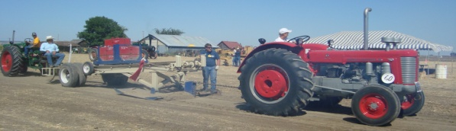

Events included; antique tractor pull, steamed corn on the cob, dutch oven bread making, working blacksmith shop, shingle branding and many more. After enjoying these activities, the museum hosted many spectators looking for more information on The Huntley Project and a nice place to cool off from the weekend heat.
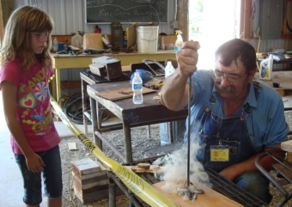
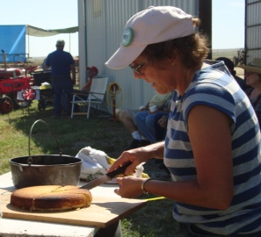

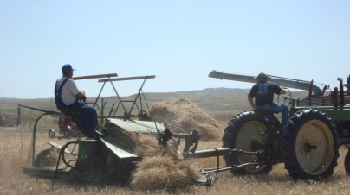
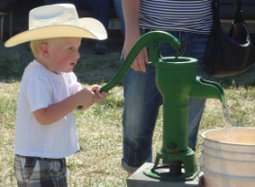

Upcoming Events

First National Bank Grand Opening
Saturday September 24th, 2011 12-4

Come see the newly restored First National Bank, originally from Pompey’s Pillar. There
will also be an Open House held in the museum center with refreshments to enjoy and exhibits
to observe. Please call or email the museum
with any questions.
curator@huntleyprojectmuseum.org
406-348-2533

Family Halloween Day & Haunted Maze
Saturday October, 29th 2011 12-4

From 12pm-4pm families are invited to come to the museum and enjoy many activities; games, face painting, pumpkin carving, and trick-or-treating around the museum grounds. Wear
your costume!

After dark there will be a haunted maze for braver (older) kids to walk thru. Get ready to be scared! Please call or email with any questions.
curator@huntleyprojectmuseum.org
406-348-2533

