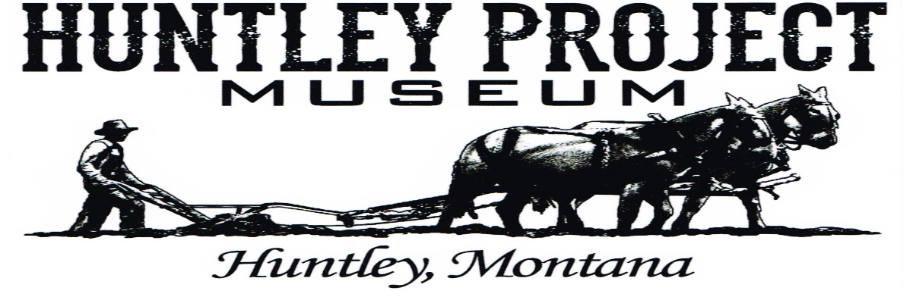
N e w s l e t t e r S p r i n g 2 0 1 5
Special Points of Interest

- Kite Flying Workshop
- Annual Members Meeting
- Museum Garage Sale
- Gay joins museum staff
- Huntley Project Museum joins
Billings Chamber of Commerce
Kite Flying Workshop At Huntley Museum

Saturday, April 25, 2015 From 1:00 to 4:00 PM

Kites provided for $5.00 each

We will be decorating them!

- Dassinger Building & The Church Nearing Completion
- Enlarged Parking Area
- Birthday Parties At HPM
- Homesteader Days
- Threshing Bee

Annual Members Meeting Saturday, May 2, 2015 at 1:00 PM
Pie and Ice Cream will be served!

Huntley Project Museum Garage Sale
Step Right Up Folks! Friday & Saturday,
May 8th & 9th from 10:00 to 4:00 PM

Gay brings a multitude of talents and abilities to our team including; vast experience as a landscaping & horticultural designer. Flora, Fauna and Arboretum care, design and maintenance. Gay also has her own cottage industry called Miss Fire Farms where she manufactures goat’s milk soaps and lotions.
Huntley Project Museum Is please to introduce the newest member of our staff, Gay Keppel
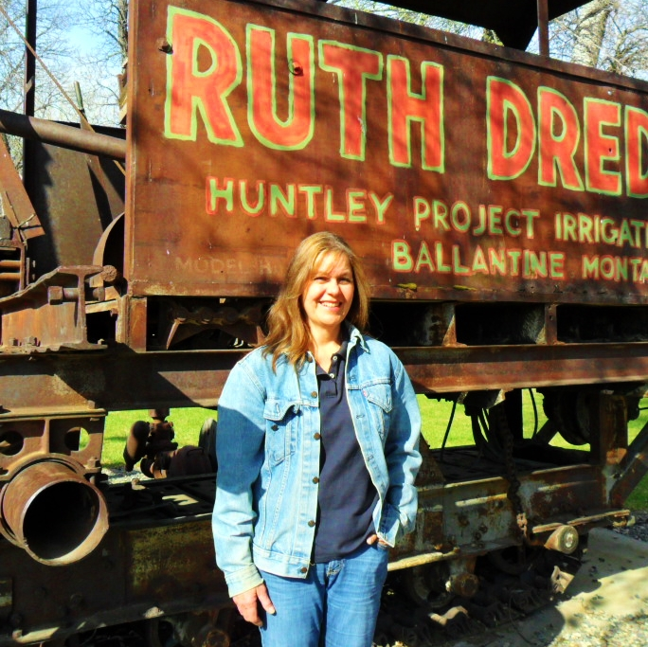 Check out her display in the museum gift shop!

Congratulations Are In Order
The Huntley Project Museum is now an official member of the
Billings Chamber of Commerce.
Wait, there’s more!
Rod Propp has completed installation of the wood floor in the Dassinger building using wood from Ed & Alma Becker’s former home, while Jim Knapp has been working hard on the electrical system. The renovations on both the Dassinger building and the church are almost completed. In addition, gravel has been added to our parking lot which has increased the size of the parking area.
Huntley Project Museum

Gift Shop has been expanded. Come in & see all the new toys, baskets, books etc.

We will have handmade quilts for sale in the near future!
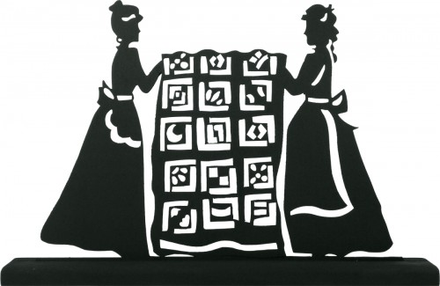
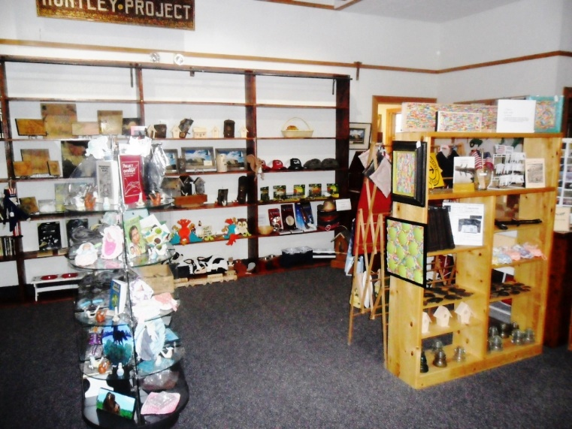
Have a Traditional Birthday Party at Huntley Project Museum!
Please Call Gay for more information on different packages #406-348-2533
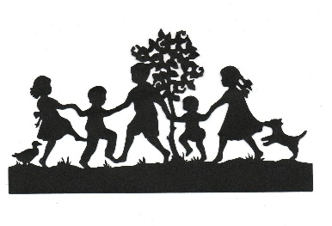
Homesteader Days
Friday & Saturday, July 10th & 11th, 2015
Friday night concert featuring Craig Morgan &
The Gatlin Brothers!
Saturday Parade, Concessions, games, craft Fair & Fireworks!
Make sure you come in and visit the Huntley Project Museum!

- Threshing Bee
Saturday & Sunday, August 15th & 16th
Featuring Oliver Tractor’s
Make sure you come in and visit the Huntley Project Museum!

HPM, 770 Railroad Hwy Huntley, MT 59037 | 406-348-2533 | www.huntleyprojectmuseum.org
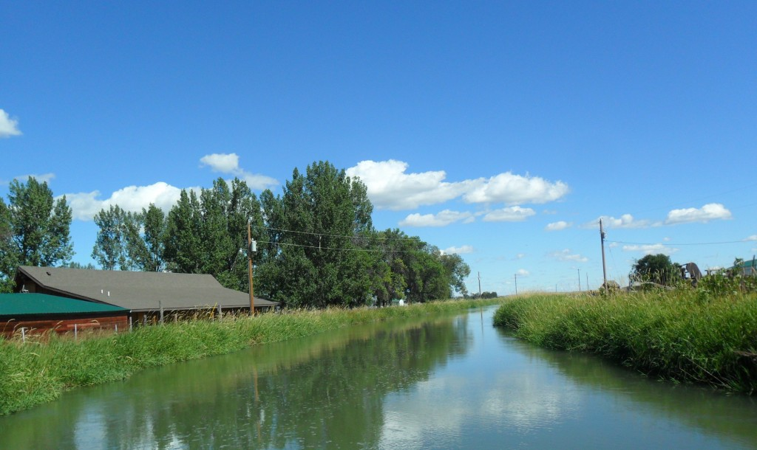
Huntley Project Museum of Irrigated Agriculture

Volunteer Interest
Volunteer:
Name:_________________________________ Phone:________________________
Address:_________________________________________________________________
_________________________________________________________________
Email:_________________________________ Birthday:______________________
Emergency Contact: ______________________ Phone: ________________________

Areas of interest:
The museum needs volunteers in the following departments. Training will be provided. Please check all that apply.
Interpretation Office
____ Visitors information/reception _____Mailings
____ Docent _____Computer input
____ Demostrations _____Gift Shop

Exhibits Facilities
_____ Construction _____Construction/renovation
_____ Layout/design _____Cleaning/maintenance
_____Gardening/grounds keeping
Collections
_____ Research Education
_____Artifact care _____Children workshops
_____Cataloguing _____ Adult workshops

Huntley Project Museum of Irrigated Agriculture

Become a member today!

Please consider becoming a member of the Huntley Project Historical Society. Your donations will help the Huntley Project Museum continue the ongoing work of preserving, interpreting, and cataloguing of our rich history.

Membership benefits:
- Discounted workshops
- Discount at museum’s gift shop
- Free access to the museum’s research library
- Invites to member only events

Thank you

Neal Gunnels
Curator/Director Huntley Project Museum

---------------------------------------------------------------------------------------------------------------------
Membership Form
Name_______________________________ Phone Number____________________________
Address__________________________________________ Email _______________________
Individual membership ($15)_____ or Family membership ($25)_______

Additional donation $ _____________
770 Railroad Hwy.
P.O. Box 353 Huntley, Montana 59037
406.348.2533
www.huntleyprojectmuseum.org
curator@huntleyprojectmuseum.org

