Interested in becoming a member of Huntley Project Museum?
Single Membership- $15
Family Membership- $25
Memberships are good for one year. With your membership the museum donation fee will be waived upon your visits. You will receive monthly museum newsletters and emails with upcoming events and museum happenings.
Please fill out information below and send along with a check to:
Huntley Project Museum
P.O. Box 353
Huntley, Montana 59037

--------------------------------------------------------------------
Name_______________________________
Address_____________________________
_____________________________________
Phone Number_____________________
Email Address________________________
Single Membership @ $15
Family Membership @ $25

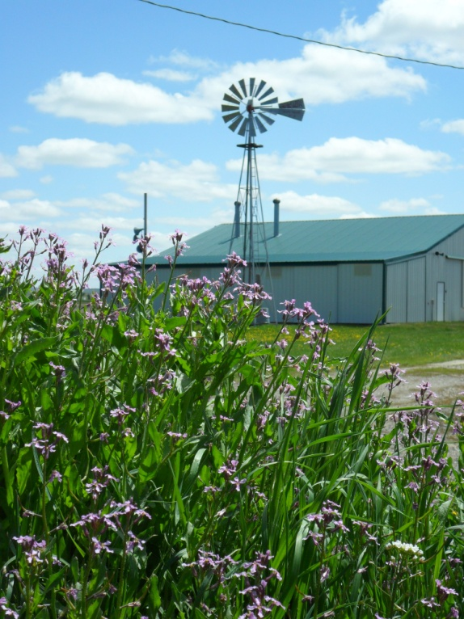

Huntley
Project Museum of Irrigated Agriculture
Summer 2011 Newsletter
Hello from Your Curator

Summer has settled in and things are picking up at the museum.

The inside of the museum building is renewed with fresh exhibits. Debuted at
the annual meeting, these exhibits feature explanations of the need and use of the irrigation system, homesteading items, and ranching equipment. The exhibits attempt
to tell a homesteading story.

Please make sure to stop by.

In the last newsletter the wrong date was printed for the museum’s car show. The correct date is August 14, 2011 with a rain out date of August 28th.

I’m in need of volunteers for the summer season. Please contact me if you’re interested.

Have a great summer!
Melissa Koch

curator@huntleyprojectmuseum.org

406.348.2533
Museum Contact Information

Melissa Koch, curator
Email: curator@huntleyprojectmuseum.org
Website:
www.huntleyprojectmuseum.org
Phone:
406.348.2533
Hours:
Tuesday-Saturday 10-4
Address:

770 Railroad Highway
Huntley, Montana 59037

Call ahead to schedule a tour, rope making, or ice cream making.

Hope to see you soon!
Upcoming Events

2nd Annual Endless Summer Car Show-August 14th
Beautiful and classic cars will be displayed at the upcoming annual event. There is a rain out date of August 28th. Please contact Melissa at 348.2533 or Bill Kraske at 861.1042 for more information

Threshing Bee- August 20th - 21st
Stop by the museum and our outbuildings on your way to the Tractor Club’s Threshing Bee, held behind the museum building.

Bank Grand Opening- TBA
Keep your eye out for our next newsletter and the Yellowstone County News for more details.

Halloween Fun Day- October TBA
Games, trick-or-treating, face painting, pumpkin carving and much more will fill your day with fun.

Museum Pictures
