Interested in becoming a member of Huntley Project Museum?
Single Membership- $15
Family Membership- $25
Memberships are good for one year. With your membership the museum donation fee will be waived upon your visits. You will receive monthly museum newsletters and emails with upcoming events and museum happenings.
Please fill out information below and send along with a check to:
Huntley Project Museum
P.O. Box 353
Huntley, Montana 59037

------------------------------------------------------
Name___________________________________________________
Address________________________________________________
_________________________________________________________
Phone Number________________________________________
Email Address__________________________________
Single Membership @ $15
Family Membership @ $25

Huntley
Project Museum of Irrigated Agriculture
Summer 2011 Newsletter

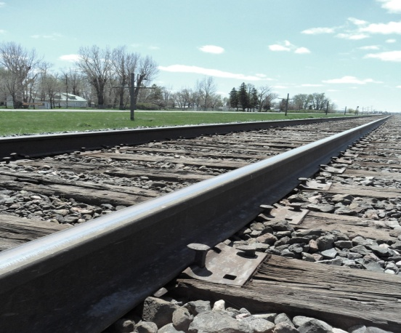

Huntley Project Museum of
Irrigated Agriculture
Spring 2012 Newsletter

It was a busy and exciting winter for the Huntley
Project Museum!

Most importantly the museum was awarded a grant by the state of Montana in the amount of $22,500. This money will cover an expansion of the museum’s turn
of the century town site and the creation of a large homestead site. Joining the current doctor’s office and bank will be 5 additional buildings and a boardwalk connecting them. The homestead site will feature a 1910 homestead house, log cabin, chicken coop, and barn with corral. Please see the sample diagram on the inside of this newsletter. Construction will begin the end of March and last through the fall.

The museum was left a generous donation by a wonderful lady and community member, Ethel
Fleming. Her donation will aid in the new town site
and create a theater in memory of Ethel, her family,
and their contributions to the Huntley Project.
There aren’t just changes happening on the outside, the inside of the museum is getting an overhaul as well. New displays and a new lay out are sure to impress. Please join us for an Open House, March 31st 2012. Come enjoy new displays, snacks, and a presentation
on the grant project. Bring questions and an appetite!

I’m elated with all the positive changes happening for the Huntley Project Museum and I look forward to sharing them with the community. Hope to see you soon!

Your Curator,
Melissa Koch
curator@huntleyprejectmuseum.org
348-2533

11

12 E
10
N S
9
W
8

7

Canal
6
5

HWY 312

4
3

2
1

Main Museum Building
TIIP Grant Project
Turn of the century town site and homestead site to be built with grant money acquired through the state department of tourism. Please join the museum for the Open House on March 31st to learn more about this exciting project.
Map Key
1 – Homestead House
2 – Chicken Coop
3 – Barn
4 – Log Cabin

5 – Barbershop
6 – Post Office
7 – Theater Hall
8 – Doctor’s Office **
9 – Church
10 – Bank **
11 – Mercantile
12 – Boardwalk

** Buildings already built and completed for display

A Big Thanks To….

Local business that supported the museum in its bid for grant funds in 2011; Miller’s Dark Horse Saloon, R&R Trading, All Around Service & Repair, and the Yellowstone County Museum.
Upcoming Events

March 31, 2012 – Open House
Come enjoy new displays, snacks, and
learn about the TIIP Grant Project!

May 12, 2012 – Huntley Project Museum’s Annual Meeting
Enjoy the museum, members, and tasty treats while we prepare for another
great summer season

July 13-14, 2012 – Huntley Homesteader Days
Sponsored by the Huntley Lion’s Club.
Live concert Friday night, all day events Saturday. Parade begins at 10:30a.m. Saturday.

July 28-29, 2012 – Clark Days
Join us at Pompey’s Pillar for this great annual event

August 18-19, 2012 – 24th Annual Threshing Bee
This year the local Antique Tractor Club hosts the national threshing bee. Join us
for fun activities and great displays

Open Tuesday-Saturday 10-4
Year Round
Drop in for a daily visit, we’ll be glad to show you around the museum grounds.

