Interested in becoming a member of Huntley Project Museum?
Single Membership- $15
Family Membership- $25
Memberships are good for one year. With your membership the museum donation fee will be waived upon your visits. You will receive monthly museum newsletters and emails with upcoming events and museum happenings.
Please fill out information below and send along with a check to:
Huntley Project Museum
P.O. Box 353
Huntley, Montana 59037

------------------------------------------------------------------------------
Name_____________________________
Address___________________________
___________________________________
Phone Number___________________
Email Address____________________
Single Membership @ $15
Family Membership @ $25

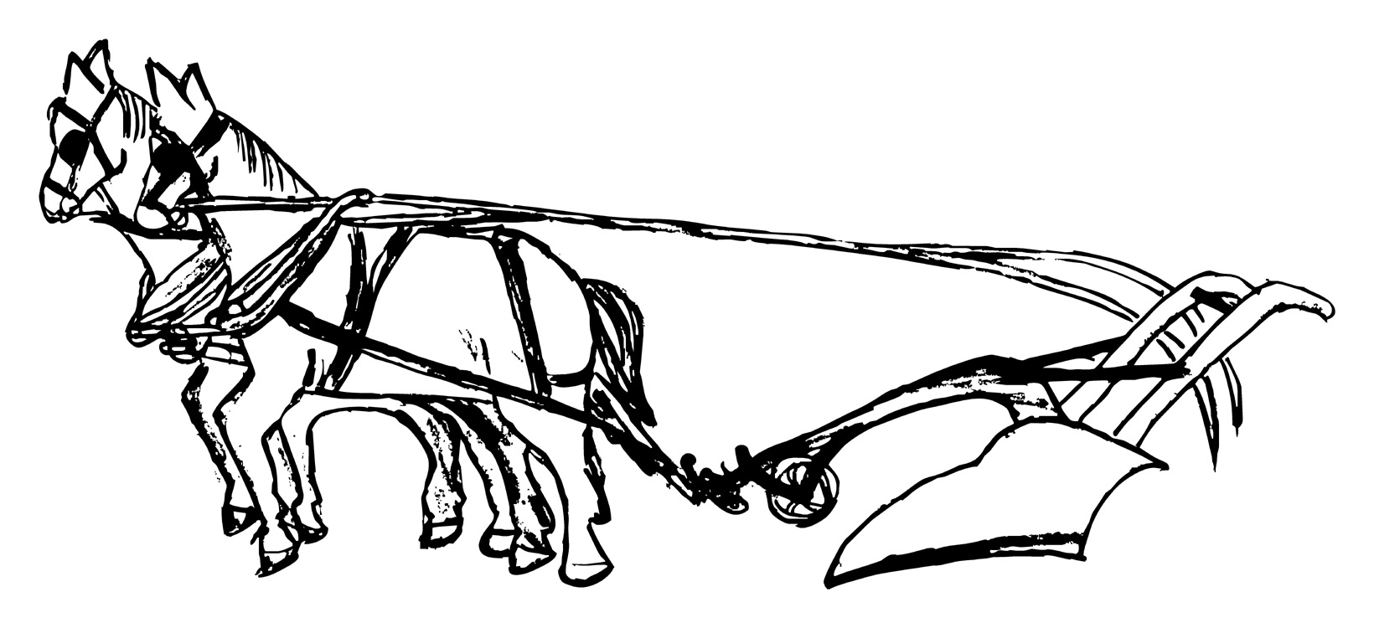
Huntley Project Museum of Irrigated Agriculture
Winter 2010 Newsletter
Hello from Your Curator

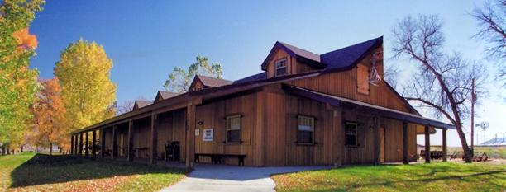
This has been an exciting and eventful fall here at the Huntley Project Museum.

The first annual Halloween Day was a
fun event that catered to children and families of the Huntley Project area
and also drew a small Billings crowd.

We’ve been lucky in new
acquisitions for our many displays.

I look forward to putting together new displays and display ideas during the winter months.

Keep an eye out for any new and
upcoming events to be advertised in
the Yellowstone County News, and at
local businesses.

As always the museum is looking for volunteers for various projects this winter. Please contact me if you’re interested.

I’m open to any questions and/or suggestions.

Stay Warm!
Melissa Koch
curator@huntleyprojectmuseum.org
www.huntleyprojectmuseum.org
406.348.2533

Tours and Visitors

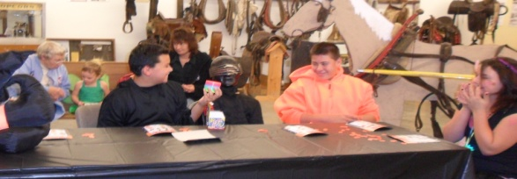
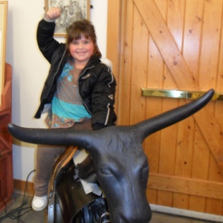
Huntley Project Elementary School’s after school program visited the museum twice in October. The first group of younger kids enjoyed a tour of the museum, a group discussion about Montana’s agriculture, and a tour through the school house, tar paper shack, and doctor’s office. Most children got their picture taken on our “bucking bull” and will receive framed magnetic pictures from the museum.

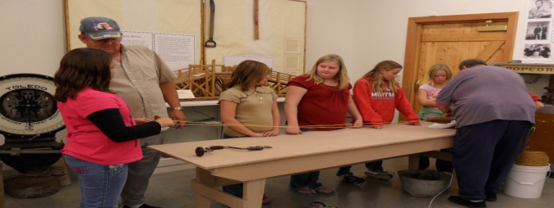
The older half of the after school group benefitted from numerous activities. Rope making with Shorty Mueller and Ernie Eddy was a popular, and the video of the 1924 beet harvest provoked a lot of questions. They also toured through the school house, homestead, and doctor’s office.
Thanks to the HP afterschool program, Shorty, Ernie, and Julie for all your help.
The Museum looks forward to hosting other school programs throughout the winter.
Halloween Day at the Museum

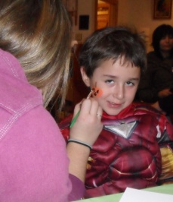
This was the first year for the Huntley Project Museum to hold a family Halloween Day. From 2pm-5pm visitors were welcomed to get their face painted, decorate trick-or-treat bags, paint or carve pumpkins, play bingo and trick-or-treat around the museum’s outbuildings.
Kids showed up in costume ready for candy and fun. The bingo game was exciting and everyone enjoyed picking out their own prizes.
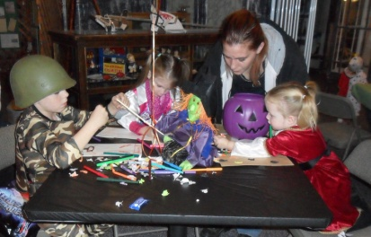
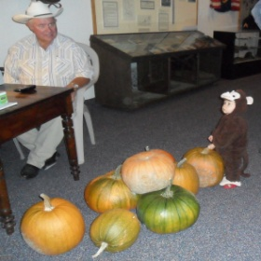
Stickers, markers, and crayons helped these kids create a unique personalized trick-or-treat bag to use while discovering the museum grounds and filling up on candy.
Thanks to Jim and Mary Knapp, Ed and Phyllis Weidinger, Allison and Julie Walsh, Morgan and Ashley Carlson, and Chase Wicks for volunteering their time at the Halloween Day.
New Acquisitions
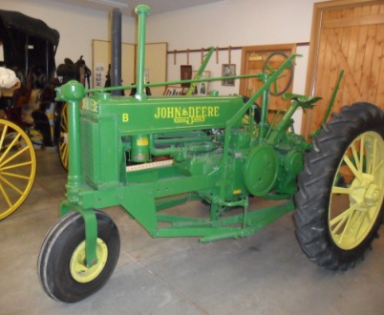
The Huntley Project Museum is lucky to add two exciting pieces to our exhibits.
A 1937 John Deere “B” Tractor was graciously donated by the Wakenshaw Family. This tractor was originally used by Charles Hoff, on the land homesteaded by his parents; Albert and Lucy Hoff located on Road 9. It’s been restored to former glory and is a wonderful new addition to the museum.
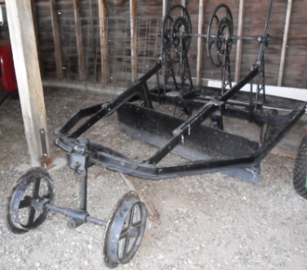
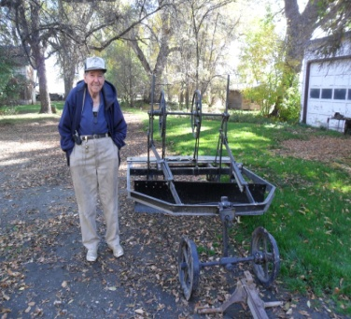
The museum also acquired an antique Road Grader, donated by Harley O’Donnell of Billings. The grader was invented by Rev. B.F. Shuart on the Hesper Farm around 1890; it was manufactured and sold by the Ohio Machinery Co. Rev. B.F. Shuart started the First Congregational Church, the first church in Billings, in 1882.

